BTEC Level 3 National Extended Certificate in Sport
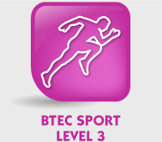
Induction Pack
Prince William School

In this induction pack you will find the following:
- Introduction to the course (what is it all about?).
- Assessment (how you will be assessed in each unit).
- Unit Summary (what each is about and the assessment objectives for each unit).
- Expectations (what we expect from you whilst completing this course).
- Useful Resources (where you can access additional support and information).
- Unit Break Down (each unit broken down to give you more information).
- Research Activities (tasks that you will be completing during the course and over the summer).
- Blank Skeleton (for one of your research tasks)
- Example Assessment Material (for the units that will be externally assessed)
Introduction to the course
Welcome to your Pearson BTEC Level 3 National Extended Certificate in Sport. This booklet is designed to introduce you to the course, to inform you of what you will be covering over the entirety of the course, how you will be assessed and to give you tasks to complete during the first two weeks of the course and over the summer.
You will be covering a broad basis of study including anatomy and physiology, fitness training and programming, professional development in the sports sector and application of fitness testing. This qualification is designed to support progression to higher education when taken as part of a programme of study that includes other appropriate BTEC Nationals or A Levels. It is equivalent in size to one A-Level and will be delivered over 360 Guided Learning Hours (GLH), you will however be expected to complete tasks, such as research in your own time in order to be successful on the course.
Please use this induction pack to help you understand the course, the assessment methods and to refer to when you need further information about the course you will be starting.
If you have any questions you must always ask your teachers.

Assessments
You will be assessed externally (by the exam board) and internally (by your teachers) during the duration of the course.
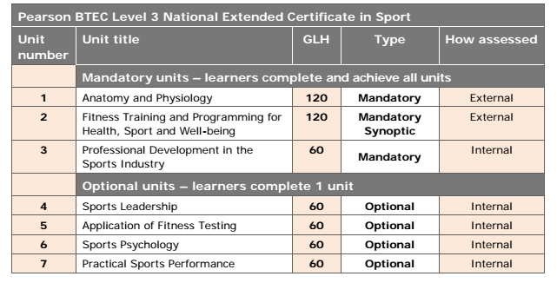
We must cover the following units (mandatory)
- Unit 1 – Anatomy and Physiology
- Unit 2 – Fitness Training and Programming for Health, Sport and Well-being
- Unit 3 – Professional Development in the Sports Industry
We will also be covering the following unit in order to cover the correct amount of GLH and to link in with the previous units delivered:
● Unit 4 – Sports Leadership

Externally Assessed Units
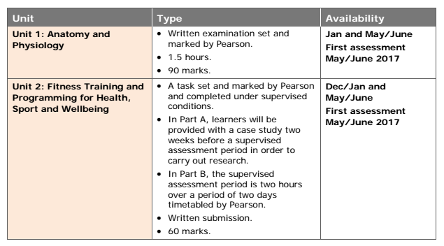
Unit Summary 4
Unit 1 - Will be assessed with a written exam
Unit 2 - Will be assessed through a set assignment by the exam board and will be externally assessed.
Unit 3 – Will be internally assessed and subject to exam board sampling of your teachers grading.
Unit 4 – Will be internally assessed and subject to exam board sampling of your teachers grading.
Expectations
In order to be successful on the course you will need to:
- Develop the ability to work independently,
- Research actively and methodically,
- Give presentations and be active group members,
- Be organised and meet all deadlines set,
- Revise thoroughly before all practise and real exams,
- Complete all work to the highest standard you are capable of,
- Keep your notes up to date and in order,
- Catch up on any work that you may miss due to absence,
- Attend any additional sessions that are put on for you,
- Always ask when you are unsure of something in lessons,
- Read through your unit outlines and apply the information when completing
tasks,
- Complete all induction work,
- Be highly motivated to achieve on the course,
- Attend all lessons, on time and with the right attitude.
Useful Resources - Recommendations
Web Sites
American College of Sports Medicine
BrianMac
British Association of Sport and Exercise Sciences Coachwise
Human Kinetics
Peak Performance
Sports Coach
Sports Coach UK
Sport Science
Top End Sports
Journals
American College of Sport Medicine’s Health and Fitness Journal
British Journal of Sports Medicine
Exercise and Sport Sciences Reviews
International Journal of Sports Science and Coaching
Medicine and Science in Sports and Exercise
Research Quarterly for Exercise and Sport
Text Books
Howley E T and Franks B D – Health Fitness Instructor’s Handbook (Human Kinetics
Europe, 2003) ISBN 9780736042109
Palastanga N – Anatomy and Human Movement: Structure and Function (Butterworth-Heinemann, 2006) ISBN 9780750688147
Sharkey B J and Gaskill S E – Fitness and Health (Human Kinetics, 2006) ISBN 9780736056144
Tortora G J and Derrickson B H – Principles of Anatomy and Physiology, 12th edition (John Wiley & Sons, 2008) ISBN 9780470233474
Adams G M – Exercise Physiology Laboratory Manual: Health and Human Performance (McGraw Hill Higher Education, 2001) ISBN 9780072489125
American College of Sports Medicine – ACSM’s Health-Related Physical Fitness Assessment Manual (Lippincott Williams & Wilkins, 2007) ISBN 9780781775496
Coulson M – The Fitness Instructor’s Handbook: A Complete Guide to Health and Fitness – Fitness Professionals (A&C Black, 2007) ISBN 9780713682250
Hazeldine R – Fitness for Sport (The Crowood Press, 2000) ISBN 9781861263360 Heyward V H – Advanced Fitness Assessment and Exercise Prescription (Human
Kinetics, 2006) ISBN 9780736057325
Howley E T and Franks B D – Health Fitness Instructor’s Handbook (Human Kinetics Europe, 2003) ISBN 9780736042109
National Coaching Foundation – Physiology and Performance – NCF Coaching Handbook No. 3 (Coachwise Ltd, 1987) ISBN 9780947850241
Powers S K and Howley E T – Exercise Physiology: Theory and Application to Fitness and Performance (McGraw Hill Higher Education, 2006) ISBN 9780071107266
Sharkey B J and Gaskill S E – Fitness and Health (Human Kinetics, 2006) ISBN 9780736056144
Watson A W S – Physical Fitness and Athletic Performance: A Guide for Students, Athletes and Coaches (Longman, 1996) ISBN 9780582091108
Wilmore J and Costill D – Physiology of Sport and Exercise (Human Kinetics, 2008) ISBN 9780736055833

Unit Breakdown
Unit 1 – Anatomy and Physiology
Unit Summary
You will explore how the skeletal, muscular, cardiovascular and respiratory systems function and the fundamentals of the energy systems.
Unit Introduction
Having an understanding of body systems is imperative in the sports industry so that professionals can help support people who are taking part in sport and exercise. The human body is made up of many different systems that interrelate to allow us to take part in a huge variety of sport and exercise activities. For example, an athlete can go from rest to sprinting in a matter of seconds, whereas an endurance athlete can continue exercising for many hours at a time.
In order to appreciate how each of these systems function, you will explore the structure of the skeletal, muscular, cardiovascular, respiratory and energy systems as well as additional factors which affect sport and exercise performance. The anatomy and physiology of each body system and their processes are very different but work together to produce movement. You will gain a full appreciation of how the body is able to take part in sport and exercise through understanding the interrelationships between these body systems.
Summary of Assessment
This unit is externally set and marked by Pearson. The examination will be one hour and 30 minutes in length. The number of marks for the examination is 80. The paper will contain a number of short and long answer questions that will assess your understanding of the following topics:
- The skeletal system,
- The muscular system,
- The respiratory system,
- The cardiovascular system
- The energy system for sports performance.
You will use this knowledge and understanding to determine the interrelationships between body systems for sports performance.
Unit 1 - Assessment Outcomes
AO1 Demonstrate knowledge of body systems, structures, functions, characteristics,
definitions and other additional factors affecting each body system
- Command words: describe, give, identify, name, state
AO2 Demonstrate understanding of each body system, the short- and long-term effects of sport and exercise on each system and additional factors that can affect body systems in relation to exercise and sporting performance
- Command words: describe, explain, give, name, state
AO3 Analyse exercise and sports movements, how the body responds to short-term and long-term exercise and other additional factors affecting each body system
- Command words: analyse, assess
AO4 Evaluate how body systems are used and how they interrelate in order to carry out exercise and sporting movements
- Command words: assess, evaluate
AO5 Make connections between body systems in response to short-term and long- term exercise and sport participation. Make connections between muscular and all other systems, cardiovascular and respiratory systems, energy and cardiovascular systems
● Command words: analyse, assess, discuss, evaluate, to what extent
Unit 2 – Fitness Training and Programming for Health, Sport and
Well-Being.
Unit Summary
You will explore client screening and lifestyle assessment, fitness training methods and fitness programming to support improvements in a client’s health and well-being.
Unit Introduction
The health and fitness industry is concerned with helping to support clients to increase their fitness levels and also ensuring a client is in appropriate health to take on a fitness programme. To work in the health and fitness industry, staff need to know how to assess clients and then be able to plan appropriate training programmes to take into account individual needs.
In this unit, you will explore the process required for screening clients and assessing their lifestyle and nutritional intake. How to interpret this information will then be examined. From this information you will explore how to make judgements on a specific individual’s current lifestyle and then suggest modifications to help improve the individual’s fitness, health and overall well-being.
Fitness training methods will be examined for each component of physical and skill- related fitness. The selection of appropriate training methods for a selected individual and their application into a training programme will then be explored. In this unit, you will draw on your learning from across your programme to complete the assessment task.
Carrying out client screening and designing fitness training programmes is an essential skill for many people working in the sports industry, including sports coaches looking to improve an individual or team’s sporting performance. Any person working in these careers would need to be able to carry out client screening and the design of training programmes in time-constrained conditions, utilising knowledge gained from previous experiences. This unit has been selected as an externally-assessed unit as it replicates the processes that are carried out in the industry, and as a synoptic unit as the knowledge and skills can be applied to the content of a number of units in the qualification.
Summary of Assessment
This unit will be assessed through a written task worth 60 marks. The task is set and marked by Pearson. The task will assess your ability to interpret lifestyle factors and health screening data from a scenario and stimulus information in order to develop and justify a fitness training programme and nutritional advice based on these interpretations.
The task will comprise two parts.
Part A - Will contain a scenario based on an individual who requires guidance on training, lifestyle, and nutrition upon which secondary research will be conducted. Part A will be released one week before the supervised assessment session (Part B).
Part B - You will then take your prepared research notes into the supervised assessment session (Part B), where you will be issued with supplementary stimulus information building on the scenario information in Part A. You will have two hours, under supervised conditions, to respond to the task. The two hour supervised assessment session must be taken in a period specified by Pearson.
Unit 2 – Assessment Outcomes
AO1 Demonstrate knowledge and understanding of the effects of lifestyle choices on
an individual’s health and well-being
AO2 Apply knowledge and understanding of fitness principles and theory, lifestyle modification techniques, nutritional requirements and training methods to an individual’s needs and goals
AO3 Analyse and interpret screening information relating to an individual’s lifestyle questionnaire and health monitoring tests
AO4 Evaluate qualitative and quantitative evidence to make informed judgements about how an individual’s health and well-being could be improved
AO5 Be able to develop a fitness training programme with appropriate justification
Unit 3 – Professional Development in the Sports Industry Unit Summary
You will explore the knowledge and skills required for different career pathways in the sports industry. You will take part in, and reflect on, a personal skills audit, career action plan and practical interview assessment activities.
Unit Introduction
The sports industry is a vast market with many different pathways. For a successful career, you need to understand the scope and breadth of the available opportunities and the steps needed to follow your chosen pathway.
In this unit, you will research the different possible careers and the associated job roles in the sports industry, then action plan your development towards achieving a
selected career aim.
You will analyse your own skills and identify how to develop them into a career through the use of a career plan. You will research your chosen career to understand how to access and progress within it. You will take part in application and interview assessment activities for a selected career pathway, drawing on knowledge and skills from across the qualification to identify your own strengths and gaps in knowledge and skills. You will evaluate your own performance to gain an understanding of the generic employability and specific-technical knowledge and skills required to access and progress in a selected career pathway in the sports industry.
This unit will prepare you for progression to a career in the sports industry either directly or through higher education, by developing your understanding of investigation, career planning and awareness of the skills and qualities that sports employers look for in a potential employee.
Unit 3 – Learning Aims
A - Understand the career and job opportunities in the sports industry.
B - Explore own skills using a skills audit to inform a career development action plan.
C - Undertake a recruitment activity to demonstrate the processes that can lead to a successful job offer in a selected career pathway.
D - Reflect on the recruitment and selection process and your individual performance.

Unit 4 – Sports Leadership
Unit Summary
Learners study what makes a good leader, the different capacities of this role, and the leadership skills and techniques necessary when leading activities in different roles.
Unit Introduction
Sports leadership takes many forms and with the sports industry growing each year, more members of society are opting to participate in sport in some way. With participation levels rising, the supervision and coaching of sport is no longer the sole responsibility of qualified professionals, such as physical education teachers and qualified coaches, but also volunteers have leadership roles. More and more individuals take up the challenge of a coaching or leadership role each year, with many volunteering in the sector.
This unit aims to develop your confidence in a variety of different roles when leading sport.
These roles range from coach, to official, to captain or personal trainer. You will be guided through the requirements of effective leadership and this will develop your knowledge and understanding of the leader’s role, the key skills, qualities and characteristics. You will be required to take on the role of a leader and demonstrate the necessary range of skills for the selected leadership role independently and as part of a team, when planning and running an event.
You will develop knowledge and understanding of sports leadership, which will guide you towards gaining a good level of confidence that would assist you in pursuing a career in a leadership role or support your progression to higher education.
Unit 4– Learning Aims
In this unit you will:
A Understand the roles, qualities and characteristics of an effective sports leader
B Examine the importance of psychological factors and their link with effective leadership
C Explore an effective leadership style when leading a team during sport and exercise activities.

Summer Activities
Over the summer period you are to work through these research tasks in order to prepare you for the course in September. You have research tasks for all four units.
Unit 1 – Research Activity Focus - Structure of skeletal system
Task 1
- Label an image of a skeleton with the major bones of the body (this must not be a pre-labelled skeleton) a copy of a skeleton has been included at the back of this booklet.
- You MUST label the following: cranium, clavicle, ribs, sternum, scapula, humerus, radius, ulna, carpals, metacarpals, phalanges, pelvis, vertebral column (cervical, thoracic, lumbar, sacrum, coccyx), femur, patella, tibia, fibula, tarsals, metatarsals.
Task 2
Describe in your own words the different types of bones, to include how they are identified (i.e. shape and size).
- You must include the following types of bone – long, short, flat, sesamoid, irregular.
- Identify these types of bone on your skeleton diagram using a colour code or numbering system.
Task 3
- Describe in your own words the different areas of the skeleton to include axial skeleton, appendicular skeleton, spine, curves of the spine, neutral spine alignment, postural deviations (kyphosis, scoliosis).
- Make sure you give appropriate examples of each within your descriptions.
Task 4
- Our bones give us the structure we need for movement and for our muscles to attach.
- You need to describe in your own words the process of bone growth; you must include information on osteoblasts, osteoclasts and epiphyseal plate.

Unit 2 – Example Assessment Material Example Scenario
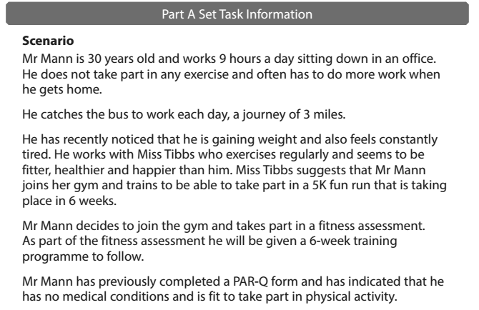
Example Tasks – to complete
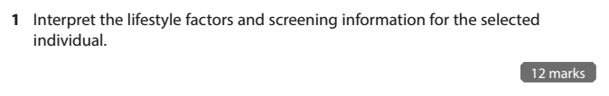

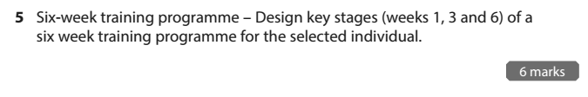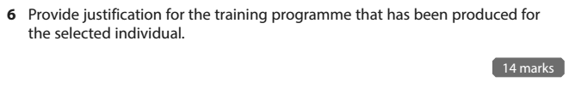

Unit 3 – Research Activities
Focus - Scope and provision of the sports industry
You will be researching the size, breadth and geographic spread of the sports industry, locally and nationally and factors that affect sports provision and employment opportunities.
Task 1
- Research the sport and recreation industry data to include the economic significance and number of jobs provided in the industry.
- Summarise your findings in a paragraph.
Task 2
- There are many factors that can impact on provision in the sports industry, research the following - Geographical factors – location, environment, infrastructure, population.
- Summarise your findings in a paragraph.
Task 3
- Socio-economic factors can impact on scope and provision in the sports industry; research the following – wealth, employment, history, culture, fashion and trend.
- Summarise your findings in a paragraph.
Task 4
- Season factors can have an impact on participation and scope of provision e.g. swimming pools that only open in the summer, summer camps, holiday sports clubs, competition seasons, training camps.
- Summarise your findings in a paragraph on the impact of seasonal factors.

Task Guidance
- All worked must be typed- apart from the skeleton
- It must be clearly labelled with each unit and what task it is.
- You can hand write your skeleton.
- Any website or book that you use must be referenced (copy and paste the web site and / or write down the name of the book and author(s))
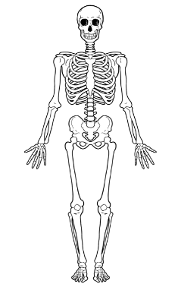

Example Assessment Material Unit 1 – Sample Assessment Material
