PiXL Gateway: Progression
- Sociology

An Introduction to A Level Sociology

It is fantastic that you are considering studying AS or A Level Sociology.
This pack contains a programme of activities and resources to prepare you to start in September. The pack is divided into some core themes that you will study in Sociology regardless of Exam Board: The Study of Society, Social Group, Theory and Methods. There are also examples of some more specific topic areas that will vary depending on your selected examination board.
Remember, if you wish to really study the world around you it is important to have a political awareness and to stay up to date with current affairs.

Contents:
- The Study of Society
- Social Groups
- Theory & Methods
- Reading List
- Independent Research

- Introduction to Sociology
Task 1:
1a. In 50-100 words, summarise what you believe Sociology to be.
2a. Now watch the following video and add to your notes, summarising what you believe Sociology to be. https://www.youtube.com/watch?v=LK5J0-cM-HE

Task 2: Morning Routine
2a. Write a list of everything that you do in the order that you do it in, in the first hour after waking up in the morning.

2b. Now consider how your daily routine compares to those of your family and peers. List what you do the same and what you do differently. What does this tell us about ourselves as individuals? Are we born with this routine or socialised into it?

2c. Find the definitions for the following concepts:
- Agents of socialisation
- Socialisation
- Primary socialisation
- Secondary socialisation
- Norms
- Values

ii. Social Groups
A core theme of A Level Sociology is different social groups. You may have come across social differences in a range of Key Stage 3 and 4 subjects even if you have not studied GCSE Sociology. You should be familiar with the concept of culture and identity.
This section is aimed at familiarising yourselves with differences related to social groups, including class, age, gender and ethnicity.

Task 3: Research definitions and complete the following glossary of key terms:
Challenge: Where appropriate, try to provide an example which illustrates the concept.

Age

Ageing population

Achieved status

Ascribed status

Culture

Ethnicity

Gender

Identity

Institutional racism

Racism

Sex discrimination

Social Class

Task 4: Complete the following research tasks and answer the questions:

Class
- Why rich kids are so good at the marshmallow test
Read the article and answer the question.
https://www.theatlantic.com/family/archive/2018/06/marshmallow-test/561779/
Questions: Define immediate gratification and delayed gratification. What does the most recent research tell us about delayed gratification? How does this link to family structure?

- The stark relationship between income inequality and crime
Read the article and answer the question.
https://www.economist.com/graphic-detail/2018/06/07/the-stark-relationship-between-income-inequality-and-crime
Questions: According this article, how does wealth influence people’s perception of crime?

Age

- NHS faces staggering increase in cost of elderly care, academics warn.
Read the article and answer the questions.
https://www.theguardian.com/society/2017/may/24/nhs-faces-staggering-increase-in-cost-of-elderly-care-academics-warn-dementia
Questions: What impact is an ageing population having on public services? Is there anything that can be done to change this?

Gender

- Miss America waves bye-bye to bikinis
Read the article and answer the questions.
https://www.bbc.co.uk/news/entertainment-arts-44370240
Questions: What factors have contributed to making this change? How does this link to the objectification of women? How would feminists view this?

- The dark side of female empowerment: The rise of Britain's 'gangster girls' running gangs
Read the article and answer the question.
http://www.telegraph.co.uk/women/womens-life/10857716/Britains-gangster-girls-The-dark-side-of-female-empowerment-The-rise-of-women-and-females-running-gangs.html
Question: Are the rise of ‘girl gangs’ a direct effect of female liberation? How else could they be explained?

Ethnicity

- Met ‘use more force’ against black people
Read the article and answer the question.
https://www.bbc.co.uk/news/uk-england-london-44214748
Question: Summarise the statistics presented in this article. Is this evidence of institutional racism or wider racism in society?

- Secret teacher: The emphasis on British History is depriving students of balance
https://www.theguardian.com/teacher-network/2018/may/26/secret-teacher-history-bias-school-fear-student-future
Question: Define the term ethnocentric curriculum. What changes would you suggest need to be made, if any, to the UK’s education system?

ii. Theory & Methods

Task 5: Consensus vs. Conflict Theory

https://www.youtube.com/watch?v=2wFPajHuluE

Question: What is the difference between consensus and conflict theory’s approaches to studying society?
Task 6: Complete the following glossary of key terms:
Challenge: Give an example of a topic area where sociologists would use this research method for their investigation.
Documents
- Personal
- Public
- Historical
Experiments
- Lab
- Field

Interviews
- Structured
- Unstructured
- Semi-structured
- Focus groups
Official statistics

Observations
- Covert
- Overt
- Participant
- Non-participant
- Structured

Questionnaires
- Closed questions
- Open questions

iv. Suggested Resource Lists
At AS and A Level Sociology it is expected that you have been partaking in wider reading. Below is a list of books/journals and Film/TV that you could use over the next two years to support you with your A Level Sociology studies.
The list includes a range of materials for each exam board. Find out your exam board from your teacher before you purchase any books. Use your local library, online libraries or ask at your local colleges and universities if you can access the books through their libraries.

A Level Sociology Textbook – you MUST have this for when you start Year 12 in September:
OCR Sociology for A Level Book 1, Sue Brisbaine (2015)
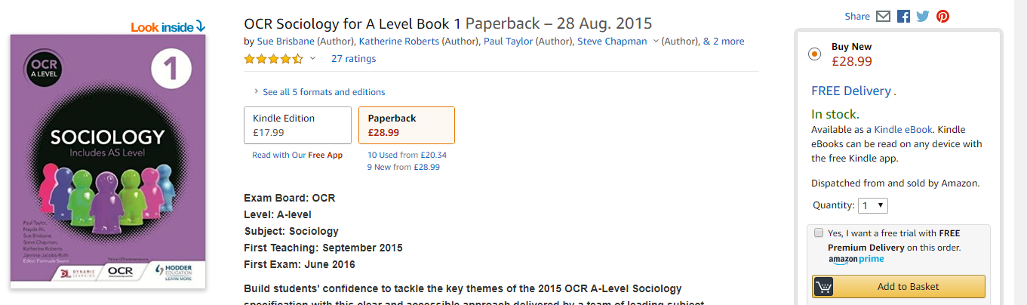
OCR Sociology for A Level Book 2, Sue Brisbaine (2016)
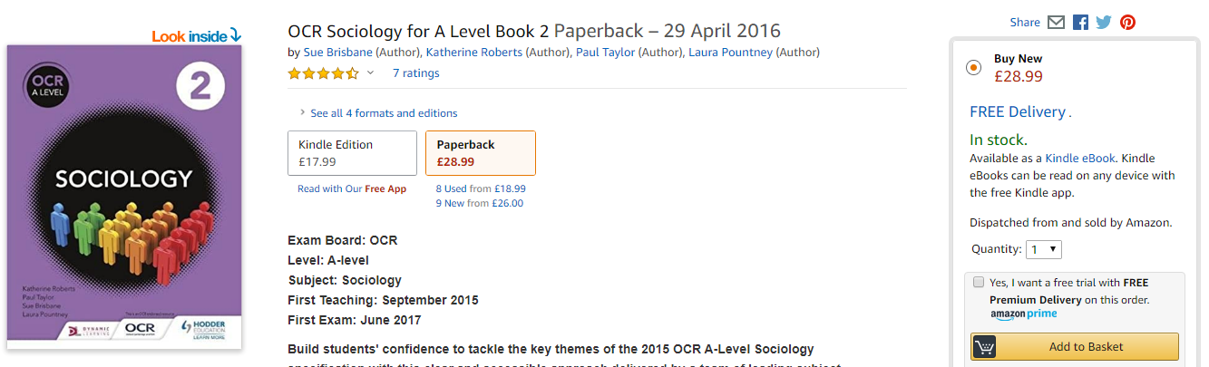

Pre-course Wider Reading Suggestions for Sociology A Level: Non-Fiction
‘The Sociology Review’, A Level magazine: Hodder Education. By subscription or in school library.
Ain't I a Woman? Black Women and Feminism, Bell Hooks (1981)
Black Like Me, John Howard Griffin (1961)
Freakonomics, Steven D. Levitt & Steven J. Dubner (2006)
Chavs: The Demonisation of the Working Class, Owen Jones (2011)
Gang Leader for a Day, Sudhir Venkatesh (2009)
Gender Trouble: Feminism and the Subversion of Identity, Judith Butler (1990)
Respectable: The Experience of Class, Lynsey Hanley (2016)
The Call of the Weird: Travels in American Subcultures, Louis Theroux (2005)
The Nonsense of Free Will: Facing Up to a False Belief, Richard Oerton (2012)
Watching the English: the Hidden Rules of English Behaviour, Kate Fox (2004)

Documentaries/TV
Back to School with Mum and Dad (BBC)
Black and British: A Forgotten History (BBC)
Beyond the Asylum (BBC)
Harrow: A Very British School (Sky1)
Educating Essex (Channel 4)
Secret Life of Four Year Olds (Channel 4)
The Doctor Who Gave Up Drugs (BBC)

Film
Catfish (2010)
Billy Elliott (2000)
Dangerous Minds (1995)
East is East (1999)
Made in Dagenham (2010)
Freedom Writers (2007)
The Kids are All Right (2010)
The History Boys (2006)

Twitter suggestions
@TheSocReview – The Sociology Review A Level magazine
@DailySociology – sociology news every day
@SocImages – links to interesting articles and research
@TheSocyCinema – pop culture and film links with sociology
@SassySociology – a PhD student specialising in gender, ethnicity and inequalities
@LearnSoc - this is the official twitter page of one of the largest sociology website
@SociologyLens -provides links to current sociological topics, research and issues to debate

v. Independent Research: Additional ideas linking Sociology and your life situation
The following research task focuses on you as an individual in relation to your area and how factors may compare on a national scale. The tasks aim to encourage you to consider a range of sociological themes. Remember to try and view sociology as holistically as possibly.
- Street Check
View the latest demographic information for your area.
www.streetcheck.co.uk
Questions: What are employment rates in your area? What is the gender split in your area? How does the median age in your area compare to the national age?

- View Crime Statistics on your street or within a one-mile radius
Compare crime rates for your postcode and/or future university.
https://www.crime-statistics.co.uk/
Question: What does the crime information tell you about the respective areas? What does the crime information not tell you about the respective areas?

