Year 11 Year 12 Dance

These 6 practitioners we study in theory and practically.

Rambert Dance Company

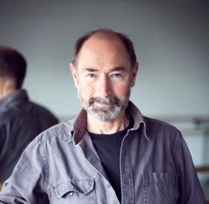 | Christopher Bruce | - https://www.rambert.org.uk/performance-database/people/christopher-bruce/  - https://www.scottishballet.co.uk/profile/christopher-bruce  - Rooster : https://www.youtube.com/playlist?list=PL4F3B261E734B7D91  - Ghost Dances snippet: https://www.youtube.com/watch?v=E0o2PEewTu8  - Swan Song snippets: https://www.youtube.com/watch?v=nyG4UELeukg&t=80s  https://www.youtube.com/watch?v=038BdfaaVVs
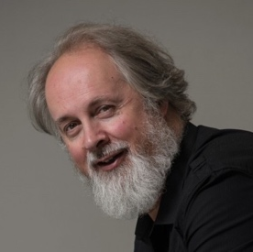 | Richard Alston | - https://www.rambert.org.uk/performance-database/people/richard-alston/  - https://www.richardalstondance.com/richard  - Examples of style: https://www.youtube.com/watch?v=4XnqJLBD4Lw  https://www.youtube.com/watch?v=O5uCkjcjoiU  https://www.youtube.com/watch?v=LQF3HQoTAfs
 | Robert North | - https://www.rambert.org.uk/performance-database/people/robert-north/  - https://www.sarasotaballet.org/robert-north  - Lonely Town, Lonely Street snippet : https://www.youtube.com/watch?v=8_GZf7iBzSE  - Death & the Maiden : https://www.youtube.com/watch?v=6wbULxDtNXg  - Examples of style : https://www.youtube.com/watch?v=LQF3HQoTAfs

The Independent Contemporary Dance Scene

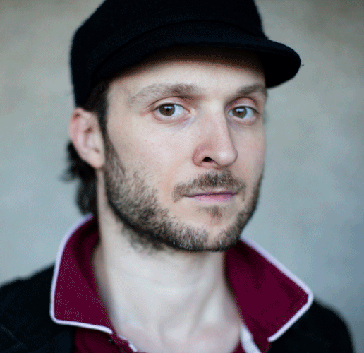 | Sidi Larbi Cherkaoui | - http://www.east-man.be/en/35/Sidi-Larbi-Cherkaoui  - http://www.roh.org.uk/people/sidi-larbi-cherkaoui  - Sutra : https://vimeo.com/202670621  - Foi snippet : https://www.youtube.com/watch?v=91ssKkERDpw&t=46s  - Babel snippet : https://www.youtube.com/watch?v=GhTQ86gY3qk
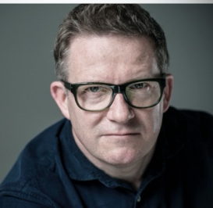 | Matthew Bourne | - https://new-adventures.net/profile/sir-matthew-bourne-obe#overview  - https://new-adventures.net/take-part/schools  - Swan Lake : https://www.youtube.com/watch?v=rQsECoq9XGM&t=632s  - Cinderella snippet : https://www.youtube.com/watch?v=9znTElT2wlA  - Example of style : https://www.youtube.com/watch?v=bxOfxBA7TCk
 | Akram Khan | - https://www.akramkhancompany.net  - https://www.theguardian.com/culture/2010/sep/27/akram-khan-dance-life  - Zero Degrees snippet : https://www.youtube.com/watch?v=1g5fLgsSQWU  - Example of style : https://www.youtube.com/watch?v=fVRHpIayzWA  https://www.youtube.com/watch?v=AcBuahXSiWU

Here is a full list of choreographers we look at in practical lessons – feel free to youtube! Maybe create a list of ones you like!

Rambert Dance Company (formerly Ballet Rambert) (1966–2002)
- Christopher Bruce
- Glen Tetley
- Robert North
- Richard Alston
- Siobhan Davies
- Ashley Page

The Romantic Ballet Period:
- Jean Coralli and Jules Perrot
- Filippo Taglioni
- August Bournonville
- Arthur Saint-Léon

The origins of American modern dance (1900–1945)
- Martha Graham
- Loie Fuller
- Isadora Duncan
- Ruth St Denis
- Doris Humphrey

American jazz dance 1940–1975
- Stanley Donen and Gene Kelly
- Agnes de Mille
- Jack Cole
- Jermone Robbins
- Bob Fosse
The independent contemporary dance scene in Britain (2000–current)
- Sidi Larbi Cherkaoui
- Shobana Jeyasingh
- Matthew Bourne
- Jasmin Vardimon
- Akram Khan
- Hofesh Shechte

