Prince William School Sixth Form

Personal Development Profile
2020-2022

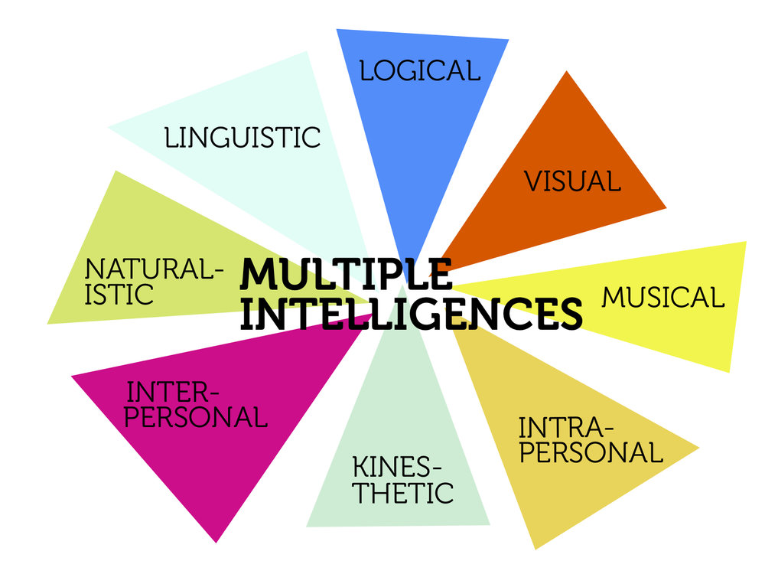

Student Name:…………………………………………..

Tutor Group:………………………………………………

Tutor Name:………………………………………………
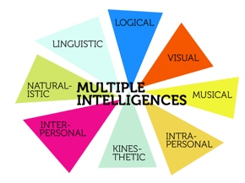
Prince William School
PURPOSE OF THE PROFILE

One of the most important success measures for any Sixth Form student is achieving the necessary entry requirements for post 18 provisions, be that entry to an higher apprenticeship, university, work based placement or full time employment.

However, academic results alone won’t ensure success in selection processes, higher level study and an ensuing career. Here, softer, personal skills will come to the fore; the ability to present, communicate and negotiate, understand team dynamic, manage risk, socialise, empathise, problem solve, be creative, flexible, motivated and resilient, will be crucial factors. Such skills, coupled with excellent examination results, will make Prince William School Sixth Formers extremely employable.

The Personal Development Profile (PDP) will provide the framework through which all Sixth Form students will plan for and then achieve their best possible examination outcomes, while also maximising gains made in the development of their personal skill sets. This framework also builds upon the employability skills you developed throughout years 7 to 11.
THE FRAMEWORK FOR THE PDP

This PDP framework will follow Garner’s multiple intelligences model. This recognises a series of intelligences that are present in all individuals to varying degrees and relate to the soft skills and employability traits we wish to grow. To be “fully human” and therefore able to achieve in all environments and situations, students should try to develop in all areas of their intelligences.

The areas of intelligences are: naturalist/environmental, musical, logical/mathematical, existential/moral, interpersonal, kinaesthetic, linguistic/verbal, intrapersonal and spatial.

SUPPORTING THE PDP

Each Sixth Form student is part of a smaller tutor group who are monitored by their Form Tutor. Each student will also have a bi-weekly PDP timetabled session with the Director of Sixth Form and weekly assemblies which will address many key areas for personal development.

The PDP will provide the framework through which the tutor can guide, steer and define the student’s provision, under the over-arching gaze of the Director of Sixth Form.

On entry to the Sixth Form, the student’s chosen subjects will be considered in light of the wheel of intelligences. Personal strengths will be considered and areas for development will be identified. Initial goals will be set and a weekly timetable will be agreed, with activities that address relevant aspects of the wheel of intelligences.

Each half term, this will be reviewed, in light of the most recent academic effort and achievement grades, and perceived progress made against the 9 areas of intelligences. As a result, new goals or activities will be agreed or existing provisions continued, for the coming half term.

Each Sixth Formers programme will be bespoke and relate to their strengths, needs and goals.

Areas within school to help support and develop the personal development of our Sixth Form students will include:

PDP Programme: Taught Element | PDP Programme: Assembly/workshops/outside speakers/tutor periods/student lead assemblies
Working towards goals | Driver Awareness
Dealing with problems in daily life | Listening and note taking skills
Working as part of a group | Communication skills
Developing self | Leadership development: SSLT/CSLA
Managing social relationships & keeping safe using social media | Careers and IAG
Individual rights and freedoms | Debating group
Community in action | Alcohol and drugs awareness
Healthy living and living on a budget | Sexual health
Revision techniques | Extremism
Preparation for the world of work | Bullying in the workplace
Managing money | E-safety
Post 18 destinations IAG | Homophobic bullying/Stonewall
UCAS process | British Values
Writing a personal statement | Managing Stress
 | Duke of Edinburgh Scheme
 | Citizenship Award Scheme
 | Interview skills workshops
 | Time management
 | Oxbridge advice and guidance
 | Sustainability and our environment

The above, as indicated, are to be facilitated through a combination of PDP sessions, assemblies, tutor periods, subject lessons, outside speakers, student lead assemblies and one2one meetings with key members of the sixth form team.

BENEFITS AND OUTCOMES OF THE PDP

- Focused mentoring of academic outcomes both the Tutor and the Director of Sixth Form.

- Constructive and productive relationships between the student and tutor and Director of Sixth Form.

- Realisation of the benefit of the depth of study delivered by A Level/BTec qualifications, while encouraging the breadth of benefit through additional provision to address the multiple intelligences e.g., Duke of Edinburgh’s award, Sports Leaders, EPQ, activities and community service throughout the school and wider community, for example.

- Development of key skills for employment.

- Creation of a full and productive weekly timetable, which engages the student.

- Development of all areas of personal soft skills.

- A Sixth Form experience that fuels individualised multifaceted personal statements and CVs.

AUTUMN TERM

ACTIVITY LINK TO MI TARGET/CHALLENGES

1 …………………………………... ……………………………. ………………………………………………..

…………………..…….……….. ……………………………. ……………………………………………….

……………………….……….. … …………………………… ………………………………………….……

2 …………………………………… ………………………….. ………………………………………….…..
.
………………………….……….. ………………………….. …………………………………………..….

………………………………….. ………………………….. ………………………………………….…..

3 ………………………………….. ………………………….. ………………………………………….…..

………………………………….. ………………………….. ………………………………….………....

………………………….……….. ………………………….. ………………………………………….….

4 …………………………………... ………………………….. ……………………………………….….….

………………………………..…. ………………………….. …………………………………….………..

……………………………………. ………………………….. …………………………………….………..

5 ……………………………………. ………………………….. …………………………………….………..

……………………………………. …………………………… ……………………………………….………
…………………………………….. …………………………… ………………………………….……………

DATE:………………………………………………………….……………………………………………………………………..

SIGNATURE OF TUTOR…………………………………………………………..………………………………….

SIGNATURE OF DIRECTOR OF SIXTH FORM………………………………………………………….
CONTRIBUTIONS TO SCHOOL LIFE

SKILLS DEVELOPMENT

_____________________________________________________________________________________________________________________________________________________________________________________________________________________________________________________________________________________________________________________________________________________________________________________________________________________________

RESPONSIBILITIES CARRIED OUT

_____________________________________________________________________________________________________________________________________________________________________________________________________________________________________________________________________________________________________________________________________________________________________________________________________________________________

INTELLIGENCES ADDRESSED
_____________________________________________________________________________________________________________________________________________________________________________________________________________________________________________________________________________________________________________________________________________________________________________________________________________________________

CONTRIBUTIONS TO THE WIDER COMMUNITY
_____________________________________________________________________________________________________________________________________________________________________________________________________________________________________________________________________________________________________________________________________________________________________________________________________________________________

SPRING TERM

ACTIVITY LINK TO MI TARGET/CHALLENGES

1 …………………………………... ……………………………. ………………………………………………..

…………………..…….……….. ……………………………. ……………………………………………….

……………………….……….. … …………………………… ………………………………………….……

2 …………………………………… ………………………….. ………………………………………….…..
.
………………………….……….. ………………………….. …………………………………………..….

………………………………….. ………………………….. ………………………………………….…..

3 ………………………………….. ………………………….. ………………………………………….…..

………………………………….. ………………………….. ………………………………….………....

………………………….……….. ………………………….. ………………………………………….….

4 …………………………………... ………………………….. ……………………………………….….….

………………………………..…. ………………………….. …………………………………….………..

……………………………………. ………………………….. …………………………………….………..

5 ……………………………………. ………………………….. …………………………………….………..

……………………………………. …………………………… ……………………………………….………
…………………………………….. …………………………… ………………………………….……………

DATE:………………………………………………………….……………………………………………………………………..

SIGNATURE OF TUTOR…………………………………………………………..………………………………….

SIGNATURE OF DIRECTOR OF SIXTH FORM………………………………………………………….

CONTRIBUTIONS TO SCHOOL LIFE

SKILLS DEVELOPMENT

_____________________________________________________________________________________________________________________________________________________________________________________________________________________________________________________________________________________________________________________________________________________________________________________________________________________________

RESPONSIBILITIES CARRIED OUT

_____________________________________________________________________________________________________________________________________________________________________________________________________________________________________________________________________________________________________________________________________________________________________________________________________________________________

INTELLIGENCES ADDRESSED
_____________________________________________________________________________________________________________________________________________________________________________________________________________________________________________________________________________________________________________________________________________________________________________________________________________________________

CONTRIBUTIONS TO THE WIDER COMMUNITY
_____________________________________________________________________________________________________________________________________________________________________________________________________________________________________________________________________________________________________________________________________________________________________________________________________________________________

SUMMER TERM

ACTIVITY LINK TO MI TARGET/CHALLENGES

1 …………………………………... ……………………………. ………………………………………………..

…………………..…….……….. ……………………………. ……………………………………………….

……………………….……….. … …………………………… ………………………………………….……

2 …………………………………… ………………………….. ………………………………………….…..
.
………………………….……….. ………………………….. …………………………………………..….

………………………………….. ………………………….. ………………………………………….…..

3 ………………………………….. ………………………….. ………………………………………….…..

………………………………….. ………………………….. ………………………………….………....

………………………….……….. ………………………….. ………………………………………….….

4 …………………………………... ………………………….. ……………………………………….….….

………………………………..…. ………………………….. …………………………………….………..

……………………………………. ………………………….. …………………………………….………..

5 ……………………………………. ………………………….. …………………………………….………..

……………………………………. …………………………… ……………………………………….………
…………………………………….. …………………………… ………………………………….……………

DATE:………………………………………………………….……………………………………………………………………..

SIGNATURE OF TUTOR…………………………………………………………..………………………………….

SIGNATURE OF DIRECTOR OF SIXTH FORM………………………………………………………….

CONTRIBUTIONS TO SCHOOL LIFE

SKILLS DEVELOPMENT

_____________________________________________________________________________________________________________________________________________________________________________________________________________________________________________________________________________________________________________________________________________________________________________________________________________________________

RESPONSIBILITIES CARRIED OUT

_____________________________________________________________________________________________________________________________________________________________________________________________________________________________________________________________________________________________________________________________________________________________________________________________________________________________

INTELLIGENCES ADDRESSED
_____________________________________________________________________________________________________________________________________________________________________________________________________________________________________________________________________________________________________________________________________________________________________________________________________________________________

CONTRIBUTIONS TO THE WIDER COMMUNITY
_____________________________________________________________________________________________________________________________________________________________________________________________________________________________________________________________________________________________________________________________________________________________________________________________________________________________

AGREED TIMETABLE

AUTUMN TIMETABLE
 | MON | TUE | WED | THU | FRI | WEEKEND
P1
BREAK
P2
LUNCH
P3
EVENING

AGREED TIMETABLE

SPRING TIMETABLE
 | MON | TUE | WED | THU | FRI | WEEKEND
P1
BREAK
P2
LUNCH
P3
EVENING

AGREED TIMETABLE

SUMMER TERM

 | MON | TUE | WED | THU | FRI | WEEKEND
P1
BREAK
P2
LUNCH
P3
EVENING

MULTIPLE INTELLIGENCES

NATURALIST/ENVIRONMENTAL

This area focusses on our understanding of the natural world; it is particularly relevant to environmental issues and the future preservation of our planet.

Subjects and activities that would further your ability in this area might include Geography, Biology, the Duke of Edinburgh’s award etc. This intelligence would also be developed by a relevant EPQ.

MUSICAL

This area focusses on ability to discern rhythm, pitch and tone. It enables creativity, reproduction, appreciation and constructive reflection of music and sound. Development of creative thought fuels problem solving and is a skill which is sought after by employers.

Subjects and activities that would further your abilities in this area might include Music, peripatetic music lessons, involvement with choirs, orchestras and groups assisting the lower years with music. This intelligence would also be developed by a relevant EPQ.

LOGICAL/MATHEMATICAL

This area focusses on the ability to calculate, quantify, hypothesise and complete mathematical operations. It enables us to establish relationships and use abstract symbolic thought, sequential reasoning and inductive thinking patterns.

Subjects and activities that would further your abilities in this area might include Mathematics, Chemistry, Physics, Computer Science and involvement in a Chess club. This intelligence would also be developed by a relevant EPQ.

EXISTENTIAL/MORAL

This area focusses on sensitivity and the ability to deal with deeper questions and dilemmas of human existence. Understanding here, can grow skills in learning and adapting which are relevant in most fields of employment.

INTERPERSONAL

This area focusses on the ability to understand and interact effectively with others. It involves effective verbal and non-verbal communication and a high level of emotional intelligence. The skills of explanation, effective teamwork, listening and acting on instruction are key here and very desirable for employers.

Subjects and activities that would further your abilities in this area might include Drama, English, Psychology, Business Studies, a debiting society, Duke of Edinburgh’s award, Sports Leaders courses or any position of responsibility and leadership or mentoring roles for younger students. This intelligence would also be developed by a relevant EPQ. Subjects and activities that would further your abilities in this area might include Religion, Philosophy and Ethics, History, engaging with assembly themes, providing a role of responsibility in mentoring or morally supporting younger students. This intelligence would also be developed by a relevant EPQ.

KINESTHETIC

This area focusses on the ability to manipulate objects and use physical skills. It enhances a sense of timing and perfection of physical skills through mind-body union (visualisation).

Subjects and activities that would further your abilities in this area might include PE, Drama, Art, Food Science, Textiles, PE sessions, Sports Leaders courses, dance, Duke of Edinburgh’s award and leading and coaching in any of these activities lower down the school. This intelligence would also be developed by a relevant EPQ.

LINGUISTIC/VERBAL

This area focusses on conveying language successfully to negotiate, express and understand complex meaning; again, employment relevant skills.

Subjects and activities that would further your abilities in this area might include French, Spanish, English, Drama, a debating society, coaching/assisting with language lessons and clubs with younger students or presenting during assemblies or in a leadership role. This intelligence would also be developed by a relevant EPQ.

INTRAPERSONAL

This area focusses on the understanding of self in thoughts, skills and feelings. This understanding is applied to the planning and successful directing of one’s own self. An understanding of your own ability to work under pressure, organise yourself, manage stress and self-motivate are useful for employment.

Subjects and activities that would further your abilities in this area might include Psychology, Duke of Edinburgh’s award, careers, UCAS/CV and personal statement preparation, well-being and meditative activities. This intelligence would also be developed by a relevant EPQ.

SPATIAL

This area focusses on the ability to think in three dimensions. Core abilities include mental imagery, spatial reasoning image manipulation and artistic skills and active creative imagination.

Subjects and activities that would further your abilities in this area might include Art, Computer Aided Design, sports clubs and activities and craft interested. This intelligence would also be developed by a relevant EPQ.

